-22AIE203-  
Data structures and algorithms -2

**Name: Girish S Roll No.: AM.EN.U4AIE22044**

# ASSIGNMENT 4 – Minimum Spanning Tree

--------------------------------------------------------------------------



1. **Find the minimum spanning tree for the graph given below using both Prim's and Kruskal’s algorithms.**  
     
   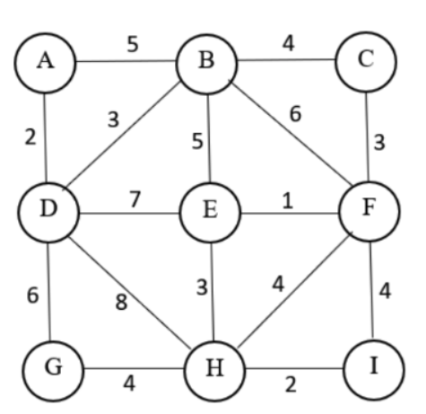

**Graph Representation using class  
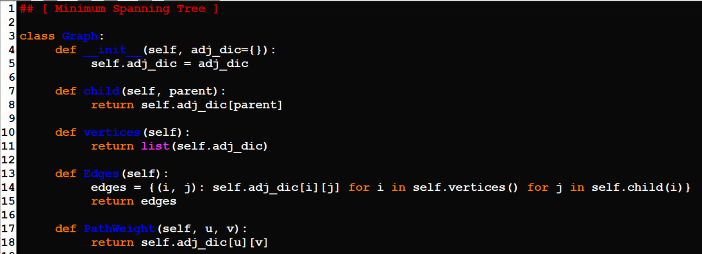  
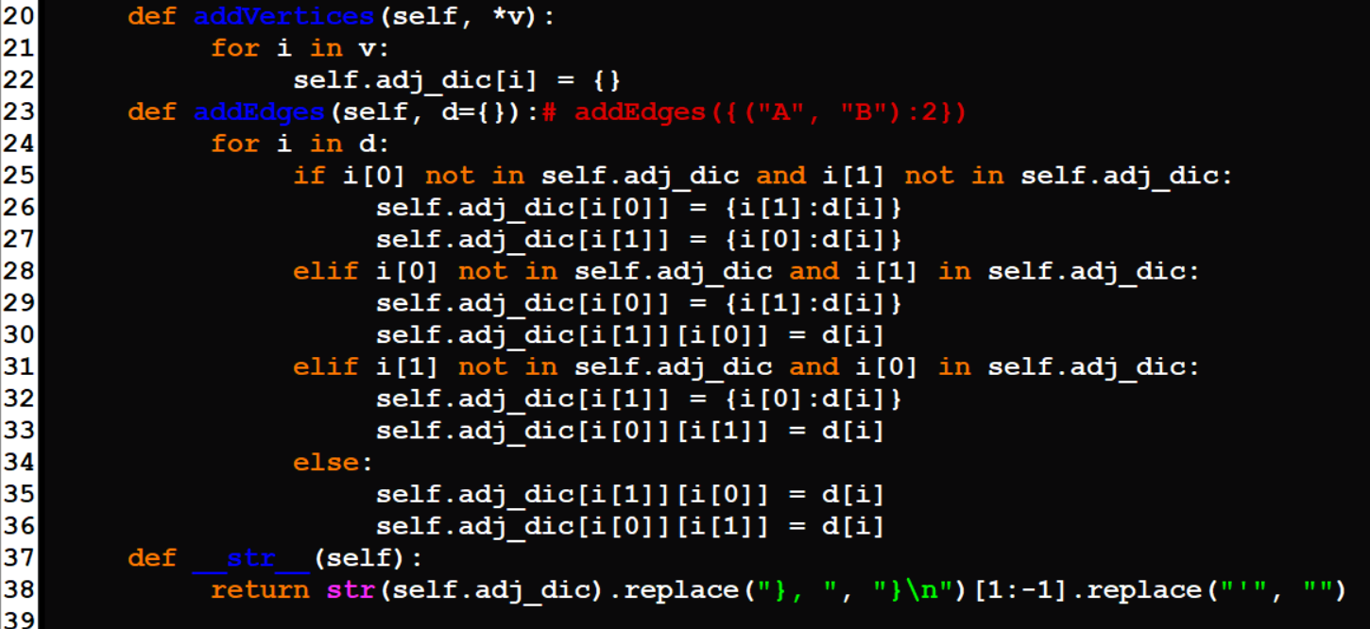  
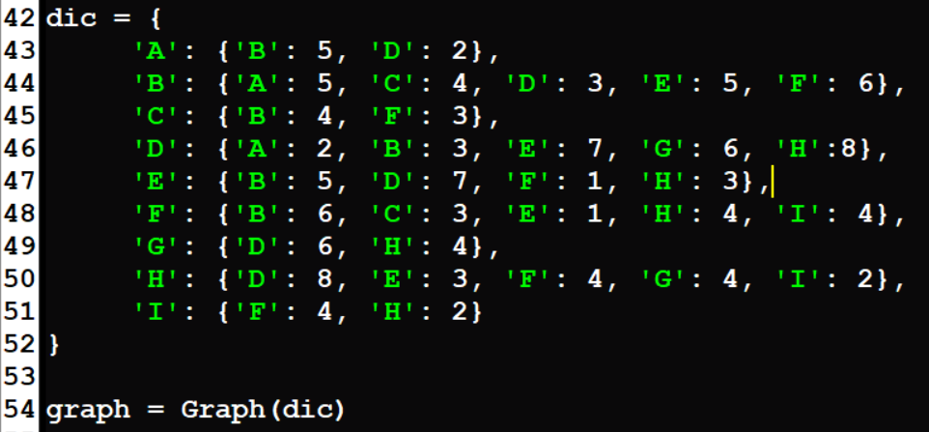**

**Prim’s Algorithm for Minimum Spanning Tree**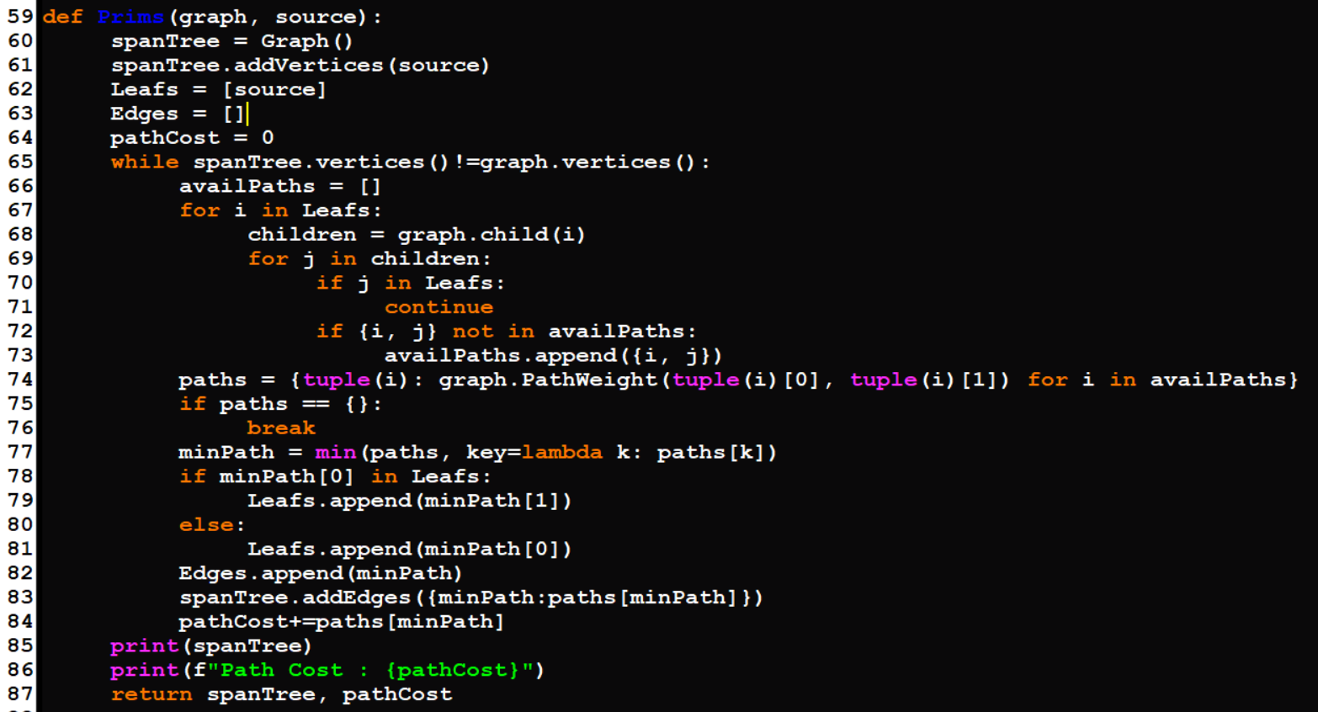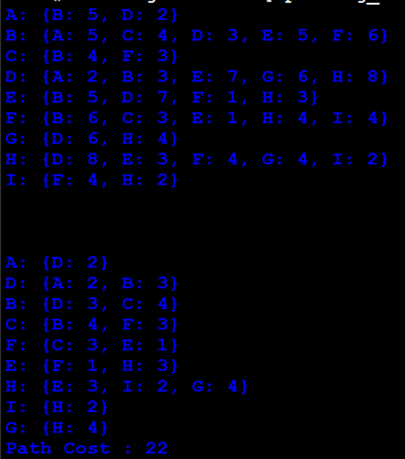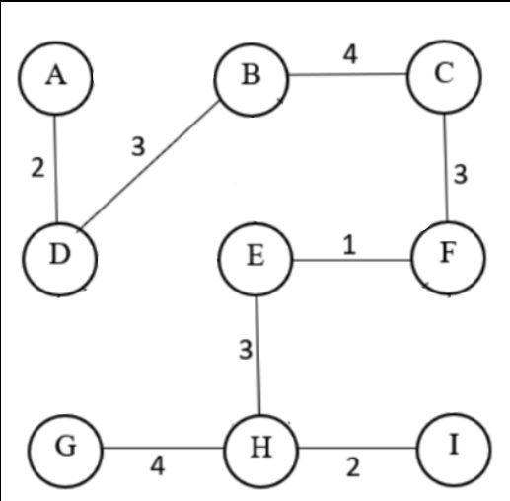

**Kruskal’s Algorithm for Minimum Spanning Tree  
